1. 
2. Git may have more than one version at a time. But working directory can contain only one version at a time.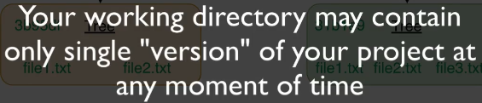
3. **Question**:
   1. How does Git know which branch is current branch?
4. 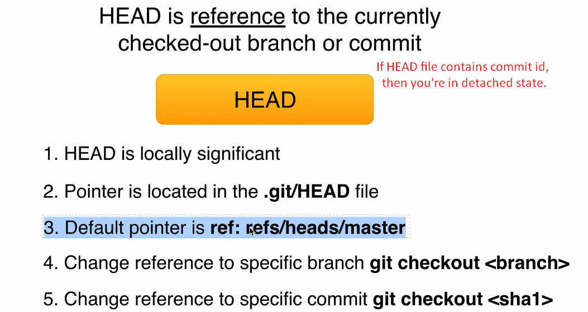
5. **HEAD is locally significant**:
   1. It means if you are working on distributed project for example hosted on Github, we can move HEAD as we want as it will not affect remote repo or remote developers.F
6. 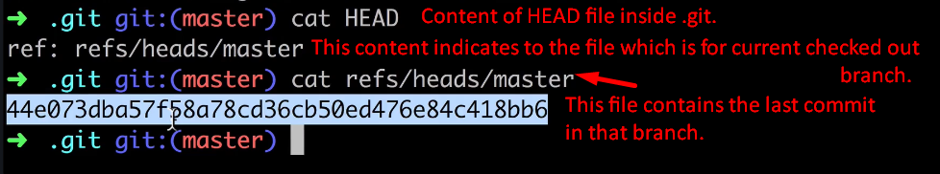
7. Jatin: Following for reference purpose:  
   A diagram of a diagram

   Description automatically generated
8. Suppose HEAD points currently to master branch as per the following:  
   A diagram of a process

   Description automatically generated  
   But after a specific commit, the head will move to that commit but master branch still point to that previous commit.  
   A diagram of a diagram

   Description automatically generated